* First, we have to create a volume For the snapshot.

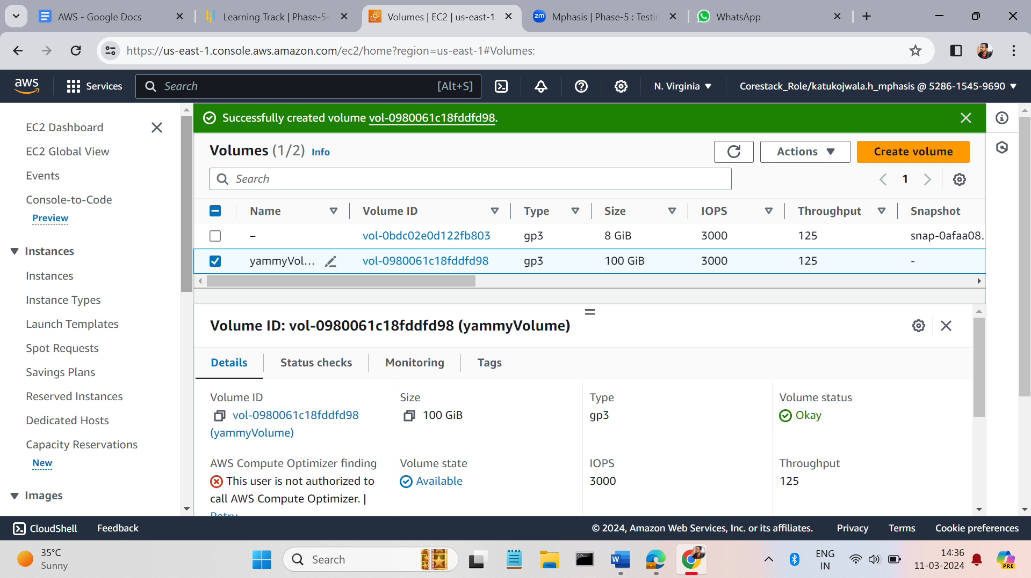

* In The Elastic Block store, we have an option like snapshot click the button. After clicking on the button you will see an option like create snapshot.  
    
  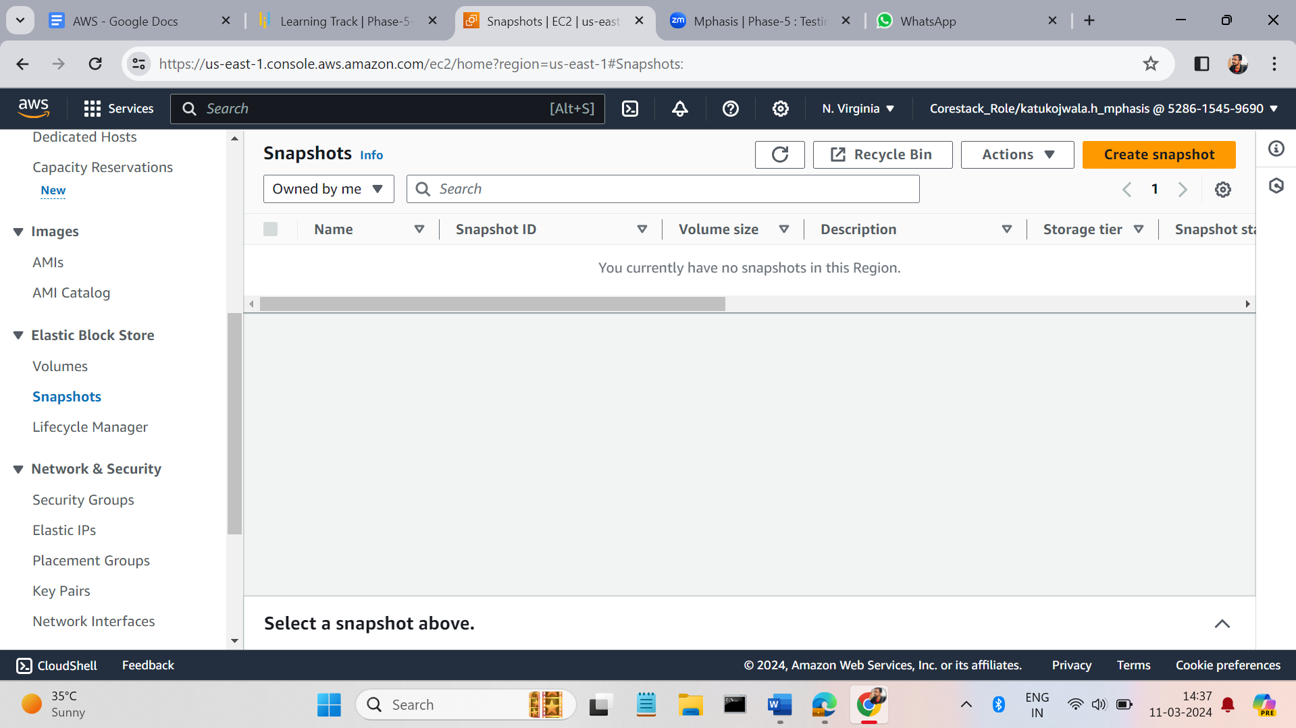
* Enter the options for which volume you want to snapshot. And click on create snapshot button.

